**GUIDE TO USING BUCKEYE CURRENT’S SIMULATION**

**Getting started:**

Download the latest version: <https://drive.google.com/folderview?id=0B67g86jkGQbKZnpDMm52SXd2dkE&usp=sharing>

Once the zipped folder has been downloaded, unzip the folder by right clicking it and clicking **Extract All.**

**Correctly Setting Up the Folder:**

There should now be a folder named test_in in the same location as Buckeye Current Simulation.exe.

Next, open test_in. This is the directory that all tests will be placed that need to be ran through the simulation. Make sure all tests are either **.txt** or **.csv** files. Having both .txt and .csv files in the folder is permitted.

**.txt** – Text file **.csv** – Comma Separated Value file

All test files must have the following parameters in the first row and its associated value in the following row:

|  |  |
| --- | --- |
| **Dist_to_alt_lookup -------------------------------** | **File name of the lookup file** |
| **Dist_to_speed_lookup --------------------------** | **File name of the lookup file** |
| **Motor_controller_eff_lookup-----------------** | **File name of the lookup file** |
| **Motor_eff_lookup -------------------------------** | **File name of the lookup file** |
| **Gearing (ratio) -------------------------------------** | **Decimal value** |
| **Step (seconds) -------------------------------------** | **Whole value** |
| **Total_time (seconds) ----------------------------** | **Whole value** |
| **Wheel_radius (meters) -------------------------** | **Decimal value** |
| **Rolling_resistance --------------------------------** | **Decimal value** |
| **Rider_mass (kg) -----------------------------------** | **Decimal value** |
| **Bike_mass (kg) ------------------------------------** | **Decimal value** |
| **Air_resistance -------------------------------------** | **Decimal value** |
| **Air_density (kg/m2) ------------------------------** | **Decimal value** |
| **Gravity (m/s2) -------------------------------------** | **Decimal value** |
| **Frontal_area (m2) --------------------------------** | **Decimal value** |
| **Top_torque (Nm) ---------------------------------** | **Whole value** |
| **Top_rpm (rpm) ------------------------------------** | **Whole value** |
| **Efficiency --------------------------------------------** | **Decimal value percentage** |
| **Chain_efficiency ----------------------------------** | **Decimal value percentage** |
| **Battery_efficiency --------------------------------** | **Decimal value percentage** |
| **Motor_torque_constant ------------------------** | **Whole value** |
| **Motor_rpm_constant ---------------------------** | **Whole value** |

The following image can be used as a reference when building a correctly formatted CSV file:

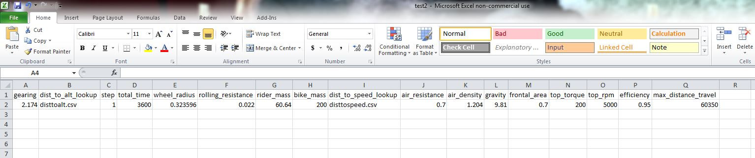

Note: parameters do not have to be in a specific order

After all test files have been generated make sure they are placed in **test_in** and not in a sub-folder such as Lookup Files. Next make sure the file names specified under the parameters **dist_to_alt_lookup**, **dist_to_speed_lookup, motor_controller_eff_lookup,** and **motor_eff_lookup** match the file names of the files in **Lookup Files**. If they don’t, rename the files in Lookup Files so they match.

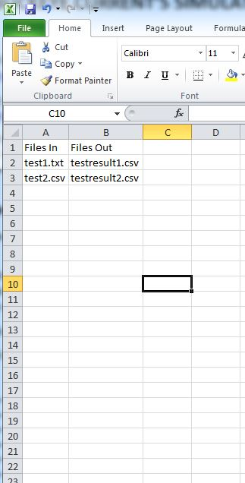Lastly, open up the file **OPTIONS.csv** in **test_in**. The file should have two columns: **Files In** and **Files Out.** Under **Files In** place all the file names of the files you want to be ran through the simulation. Under **Files Out** enter the file name for the results of the adjacent file.

The image on the right shows as an example the correct format of OPTIONS.csv. The purpose of this file is to allow users to place all tests into test_in but only run the files they specify. That way, if a user has already ran a test in test_in, they can exclude it from OPTIONS.csv and still keep it in test_in for storing it.

The user can also save in the OPTIONS.csv file the output directory for all the files. This is done in the 3rd column where the first row should be named “Output Folder” and the next row should be the full path directory.

The folder is now correctly set up!

**Running the Simulation:**

To run the simulation, simply double click **BCS.exe. CURRENTLY ONLY WINDOWS IS SUPPORTED. Contact Sean for details about running this simulation on a Mac or Linux machine.**

NOTE: Running the program for the first time, you may have to wait up to a minute before the GUI (Graphical User Interface) to pop up. Once it pops up, you should see the following screen:

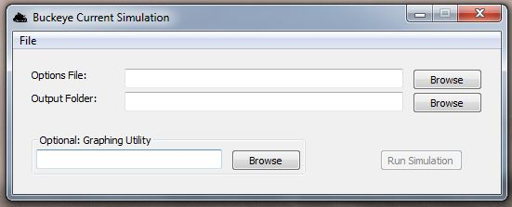

At this point, use the “Browse” button on the same line as **Options File.**  A window should pop up as follows:

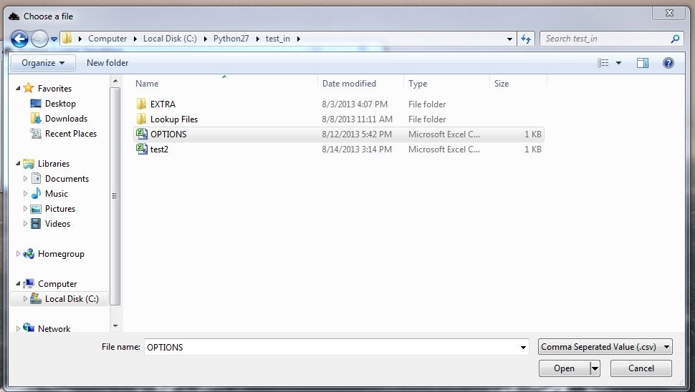

Browse for the **OPTIONS.csv** file which should be located in the folder **Simulation v0.31/test_in/**

After you have found and selected it, click **Open** on the bottom right. Next, click Browse for **Output Folder**. This is the folder the simulation will save the output files containing the calculated data. Browse to a directory of your liking and click **OK**.

If you run into any issues, look for the file “BCS_log.txt” (located in the same directory as “Buckeye Current Simulation.exe”) and email it, along with a description of the issue, the time, and the day of occurrence to Nathan or Sean.